***Real Time Communication with IoT and Morse Code Interpreter***

* **Domain:**

Instrument for Disabled

* **Objective:**

Our aim is to provide a proper instrument for **partially paralyzed individuals who are not able to speak.**

* **Abstract:**

Morse code is a [character encoding](https://en.wikipedia.org/wiki/Character_encoding) scheme used in [telecommunication](https://en.wikipedia.org/wiki/Telecommunication) that encodes [text](https://en.wikipedia.org/wiki/Written_language) characters as standardized sequences of two different signal durations called *dots* and *dashes* or *dits* and *dahs*.

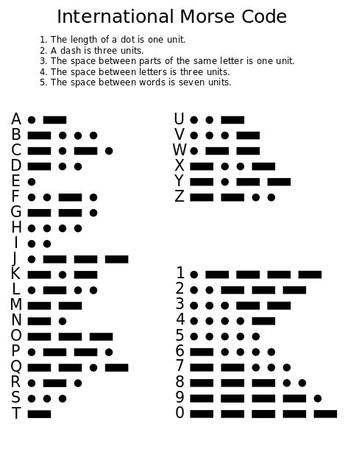

**Partially paralyzed** individuals who are not able to speak face a major problem in communicating with other peoples. They also want to speak and communicate like other peoples do. Usually this individuals have **tremors (*****Tremor****is an involuntary, rhythmic muscle contraction leading to shaking movements in one or more parts of the body. It is a common movement disorder that most often affects the hands*).Due to **tremor** this individuals are not able to work on keyboards like all of us do.

So to overcome this problem faced by this individuals we came up to an idea of using morse code for communicating with other people. As sending text messages is easy because we will provide a single button for communication instead of keyboard. Learning morse code is easy you can also find a gaming app through which you can learn morse code. The converted message will be sent to an android app because nowadays people are more familiar with smart phones and android apps.

So in this way we are planning to work for betterment of disabled people because most technology today is designed for the mass market. Unfortunately, this can mean that people with disabilities can be left behind. Developing communication tools like this is important, because for many people, it simply makes life livable.

* **Execution:**

**We are planning to make a morse code converter using ESP8266 Nodemcu and the converted code will be sent to an android app where you will be able to see the sentence.**

**All this data (i.e Converted code) will be first sent to firebase and from there to an android app.**

* **Future Scope:**

1) We can make this system more compact and fit it on wheel chair of disabled individuals and these wheel chairs would be made readily available in market.

2) We can also provide the communication app to users through playstore for android, iOS devices.